1. **INTRODUCTION**

INSERT NAME Electric Cooperative (INSERT INITIALS) is a generation and transmission cooperative that provides electric service to INSERT NUMBER member-owner cooperatives, users in Missouri. COOP INITIALS supplies electricity to meet the electrical needs of more INSERT INFO FROM YOUR COOP. This Avian Protection Plan (APP) provides the framework necessary for developing a program to reduce bird mortalities, document COOP INITIALS actions, and improve service reliability. COOP INTIALS is committed to reducing avian impacts not only for the well-being of avian species, but also to provide reliable and exceptional service to our member owners. COOP INITIALS has based this APP on input from the Avian Power Line Interaction Committee (APLIC) including documents such as: Suggested Practices for Raptor Protection on Power Lines: The State of the Art in 2012 (APLIC 2012) and Mitigating Bird Collisions with Power Lines (APLIC 2012).

1. **APPLICABLE REGULATIONS**

The USFWS has enforcement authority for three major federal laws related to bird protection. All native migratory birds in North America are protected under the federal Migratory Bird Treaty Act (MBTA) of 1918, as amended. Also, both North American eagle species are protected under the Bald and Golden Eagle Protection Act (BGEPA) of 1940, as amended. Additionally, the Endangered Species Act of 1973 provides further protection to birds considered “threatened” or “endangered.” These laws provide civil and criminal penalties for the “take” of such species.

**2.1 MIGRATORY BIRD TREATY ACT**

The MBTA implements four treaties that provide international protection to 1,026 native migratory birds (Department of the Interior 2011). Specifically, the MBTA states: “Unless and except as permitted by regulations…it shall be unlawful at any time, by any means, or in any manner to pursue, hunt, take, capture, kill… possess, offer for sale, sell…purchase…ship, export, import…transport or cause to be transported … any migratory bird, any part, nest, or eggs of any such bird… (The Act) prohibits the taking, killing, possession, transportation, and importation of migratory birds, their eggs, parts, and nests, except when specifically authorized by the Department of the Interior.” The word “take” is defined as “to pursue, hunt, shoot, wound, kill, trap, capture, or collect.” This is a strict liability statute where proof of intent is not required for a taking violation. In 1975, the Secretary of Interior clarified the broad definition of "take" by defining "harm" as:

"An act or omission which actually injures or kills wildlife, including acts which annoy it to such an extent as to significantly disrupt essential behavioral patterns, which include, but are not limited to, breeding, feeding, or sheltering; significant environmental modification or degradation which has such effects is included within the meaning of "harm."

Mortality or injury to protected species from electrocution or collision is considered a take and fully prosecutable under the MBTA. A violation of the MBTA by an individual can result in a fine of up to $15,000 and/or imprisonment for up to six months for a misdemeanor, and up to $250,000 and/or imprisonment for up to two years for a felony. Fines may be doubled for organizations (APLIC 2006).

**2.2 BALD AND GOLDEN EAGLE PROTECTION ACT**

The BGEPA provides additional legal protection for the bald and golden eagle. Punishment for the “take” of an eagle may result in a fine up to $100,000 and/or imprisonment for up to one year. Additional BGEPA provisions allow penalties up to $250,000 fine and/or two years imprisonment in the case of a second or subsequent conviction of eagle take (APLIC 2012). Bald and Golden eagles are also both protected by the MBTA.

**2.3 ENDANGERED SPECIES ACT**

Section 9 of the ESA prohibits “taking” of bird species listed as endangered or threatened under section 4 of the Act. The term “take” is defined as harass, harm, pursue, hunt, shoot, wound, kill, trap, capture, or collect, or attempt to engage in any such conduct. The term “harm” is defined as significant habitat modification or degradation that results in death or injury to listed species by significantly impairing essential behavioral patterns, including breeding, feeding, or sheltering. The term “harass” is defined as actions that create the likelihood of injury to listed species to such an extent as to significantly disrupt normal behavioral patterns which include, but are not limited to, breeding, feeding, or sheltering. However, the USFWS may, under specified circumstances, issue permits that allow the take of federally listed birds, provided that the take is incidental to, but not the purpose of, otherwise lawful activity. Non-federal entities may obtain an “incidental take permit” for the take of listed bird species after development and approval of a Habitat Conservation Plan (HCP).

1. **AVIAN PROTECTION PLAN GOALS**
2. Reduce the operational and species risks associated with avian interactions with INSERT COOP INITIALS electrical equipment and facilities
3. Maintain the confidence of the USFWS in COOP INITIALS avian protection commitment.
4. **BIRD MANAGEMENT POLICY**

Bird interactions with transmission lines may cause bird mortalities which, in turn, may result in outages, violations of bird protection laws, or raise concerns by employees, resource agencies and the public.

This policy is intended to ensure compliance with legal requirements while improving generation and transmission system reliability. COOP INITIALS management, employees, and contractors are responsible for managing bird interactions with power lines and are committed to reducing the detrimental effects of these interactions.

To fulfill this commitment, COOP INITIALS will:

* Implement and comply with its comprehensive Avian Protection Plan (APP)
* Ensure its actions comply with applicable laws, regulations, permits, and APP procedures.
* Document protected bird mortalities, potential problem poles and lines, and problem nests in order to implement corrective actions as necessary.
* Provide information, resources, and training to improve our employees’ knowledge and awareness of the APP.
* Follow procedures described in this APP during the development of new construction, or rebuild construction, in order to understand and avoid avian risks with each project.
* Construct all new or rebuilt lines, where appropriate, to raptor safe standards.
* Retrofit or modify lines, poles, and equipment where a protected bird has died, in accordance with these APP procedures.
* Manage active nest encounters in accordance with applicable laws, regulations, permits, and APP procedures.
* Participate with public and private organizations in progress and research to reduce detrimental effects of bird interactions with power lines.
* Continue to improve the APP by incorporating lessons learned, new technologies, research results, and latest laws/regulations.

Through this policy, COOP INITIALS intends to establish its leadership positions among electrical cooperatives and regulatory compliance will be enhanced as well as reducing risk to migratory birds through the proactive and innovative resolutions of bird/power line interactions.

1. **BIRD/POWER LINE PROGRAM TRAINING**

COOP INITIALS will conduct biennial training to equip distribution and transmission system personnel to:

1. Anticipate and avoid problem configurations and correct proven problem spots.
2. Properly handle, report, and remediate mortality of protected birds.
3. Know when to avoid or remove protected nests.

Key employees receiving training are Transmission and Major Construction Projects Staff, including: electrical linemen, station services, planning and technical design engineers, project and operations managers, dispatch operators, and construction supervisors.

**5.1 TRAINING SCOPE**

COOP INITIALS transmission system workers and management are trained on all components of our APP and give refresher training as significant program changes occur. Training activities include a one-hour presentation on distribution of bird identification material, and display/discussion of bird protection equipment approved for use on COOP INITIALS equipment. Key training components of the presentation are:

* Regulatory Background and Protected Bird Species – employees receive information on the MBTA, BGEPA, and the ESA, and discuss birds that are protected and those species not afforded protection.
* Bird Biology and Behavior – employees gain knowledge on bird biology and behaviors that may cause interactions with power structures. This includes bird sizes, perching, nesting, hunting, and feeding habits, as well as habitat preferences and flight path tendencies.
* Bird Mortality Reporting – employees learn to report any protected bird species found dead in or around our facilities or active protected nests removed. They are required to report these via their dispatcher or system operator. Evaluation of bird carcasses and nests to determine species and, where applicable, cause of death, is also covered. Employees understand that the cause of the incident (if it is evident), specific electrical equipment information, weather conditions, and remedial actions necessary to eliminate future threat are reporting requirements.
* Nest Encounter Reporting – employees, with an emphasis on vegetation management staff, receive guidelines to clarify company actions related to active nests of protected species. All nest encounters from vegetation management work are reported through dispatcher or system operator.
* Evaluation of High Use Areas – Trainers discuss areas of high year round and seasonal bird concentrations. Generically, these may include wetlands for waterfowl, areas of flowing water (rivers or dam tail waters) for overwintering Bald Eagles, or concentrations of carrion for turkey vultures or eagles. Location specific solutions such as substitute perches, marking static wires to improve visibility, phase covers, or perch preventers to direct birds away from conductors are reviewed.

1. **NEST MANAGEMENT**

The MBTA affords protection for…any migratory bird, any part, nest, or eggs of such bird. The MBTA specifically protects migratory bird nest from possession, sale, purchase, barter, transport, import and export, and take. The MBTA does not contain any prohibition that applies to the destruction of an unoccupied migratory bird nest alone (without birds or eggs), provided that no possession occurs during the destruction. A take occurs when an active nest—those with eggs or young birds—is removed or destroyed. Except for eagles, unoccupied nests which need to be removed can be with no requirement to report. Because eagles have special status under the BGEPA and because they may reuse their nests for several years, moving even inactive nests will be done only after consultation with management and permitting via USFWS unless there is a clearly imminent danger posed to birds or eggs, workers or electrical service.

COOP INITIALS experiences widespread bird nesting on its electrical structures, particularly in substations. This nesting often poses a safety hazard to our workers or the birds and may directly cause electrical outages or attract predators which cause outages. Safety hazards occur when COOP INITIALS personnel work in high voltage areas with active bird nests or when droppings accumulate in enclosed areas and present a breathing hazard. Bird nest-caused electrical outages are common in our service territory.

To reduce tree-related power outages, COOP INITIALS implements an intensive program to keep electrical transmission lines clear of danger trees, limbs, and other vegetation. Recognizing the potential for active nest depredation with this program, COOP INITIALS train vegetation management supervisors and contractors; provide bird identification guides and field guidelines for nest avoidance of protected species; and require reporting for all nest encounters.

When COOP INITIALS workers or contractors verify that an active nest of a protected species presents an imminent danger to the birds, human safety, or electrical service reliability, they may remove the nest immediately. This action must be reported to the workers supervisor and recorded. All other active nest encounters require strict avoidance by COOP INITIALS workers and contractors until the young birds fledge and the nest becomes unoccupied. Active nest removal requires full justification for the action to be reported through COOP INITIALS recording system. COOP INITIALS personnel will be mindful of the options of nest relocation, substitute nests, and nest platforms when the species involved and lack of urgency make these options desirable. The current active nest encounter guidelines for COOP INITIALS vegetation management are found on the following page:

ACTIVE NEST ENCOUNTER GUIDELINES

**BACKGROUND:** The purpose of these guidelines are to clarify COOP INITIALS’s requirements for contracted vegetation management as it relates to federal law and migratory bird protection. Nest destruction that results in the “take” of a protected migratory bird species is illegal and fully prosecutable under the federal Migratory Bird Treaty Act (MBTA). A “take” occurs when an active nest – those with eggs or young birds—is removed and/ or destroyed during the removal of brush, tree limbs, or entire trees. An unoccupied nest-without birds or eggs—may be removed and destroyed provided that no possession of the nest occurs. Collecting—having in your possession—an unoccupied nest is illegal and fully prosecutable under the MBTA.

**Exception:** Any active nest—in brush, on a limb, or in a tree—deemed to present an imminent danger to human safety may be removed and destroyed provided that no possession of the nest occurs. If an active nest is deemed an imminent danger to human safety, the Crew Foreman must provide sufficient justification for removal to satisfy United States Fish & Wildlife Service (USFWS) regulation and policy. Justification shall be provided on the Active Nest Encounter Record.

**GUIDELINES:**

1. Prior to removing brush, limbs, or entire trees, Crew Foreman shall survey each tree or shrub for bird nests.
2. Every bird nest shall be examined to determine whether it is active or unoccupied.
3. Active nests shall be avoided until the nest becomes unoccupied, unless meeting the noted **Exception.** Unoccupied nests may be removed and destroyed. Avoidance means that no removal occurs to the nested limb or to surrounding limbs/branches that may provide cover and protection to the nest.
4. Crew Foreman shall complete the Active Nest Encounter Record, scan and submit electronically to the COOP INITIALS project manager or environmental personnel. Encounter records shall be submitted weekly with the weekly report.
5. Prior to final nest removal, Crew Foreman shall ensure that all eggs have hatched and young birds have “fledged”, and that the nest has become unoccupied.

Once tree work is completed, Crew Foreman will fill out Date Work Completed on the original Active Nest Encounter Record form, scan and submit to the COOP INITIALS project manager or environmental personnel.

When COOP INITIALS workers or contractors encounter an active nest, the avoidance period will follow this course of action:

* If a raptor’s nest with eggs or young, return visit no earlier than July 15
* If not a raptor nest and eggs are present, return visit no earlier than six weeks from date of discovery.
* If not a raptor nest and young are present, return visit no earlier than three weeks from date of discovery

**7.0 AVIAN REPORTING SYSTEM**

Although COOP INITIALS is not required to report avian mortalities as a condition of federal or state permits, we choose to voluntarily report through our internal reporting system. The form (Attachment 1) is used by field personnel for reporting, evaluating, and documenting their recommended remedial action, if any. The avian protection program coordinator then reviews the incident and remediation for completeness and can close it out. A year-end report is created, based on this database, and submitted to the USFWS by January 31 of the following year. The one exception to this end of year reporting is for eagles. Because of their special status, Bald and golden eagle mortalities will be reported to USFWS without delay.

COOP INITIALS’s reporting system will also contain active nest encounter records. Nest encounters associated with substations or other electrical equipment will be reported through the appropriate system operator who enters the information into the system. Nest encounters associated with vegetation management require submission of a completed Active Nest Encounter (ANE) form (Attachment 2) whether the nest is avoided or removed. COOP INITIALS workers or contractors will submit close out reports of active nests avoided during the nesting season by recording the date they become unoccupied and are removed. All reports are submitted to the responsible personnel who will enter the data into the recording system.

Avian mortality and active nest encounter reporting will adhere to the following processes:

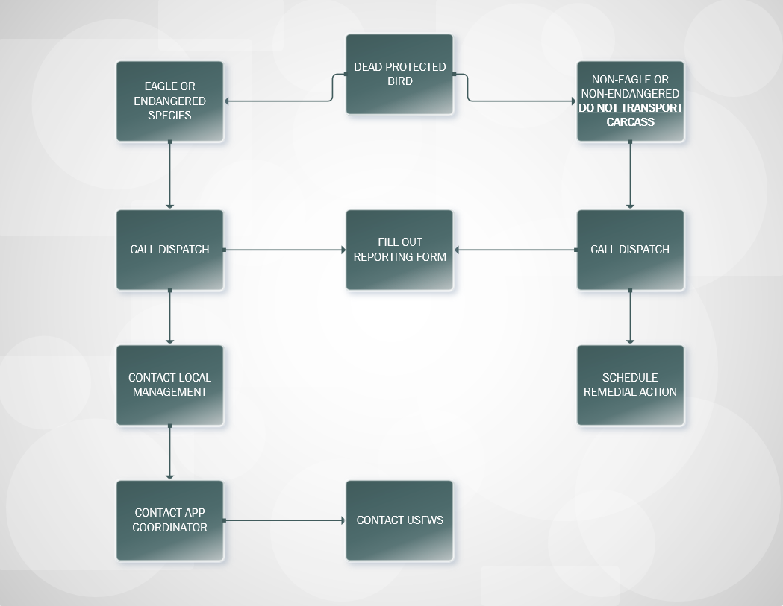

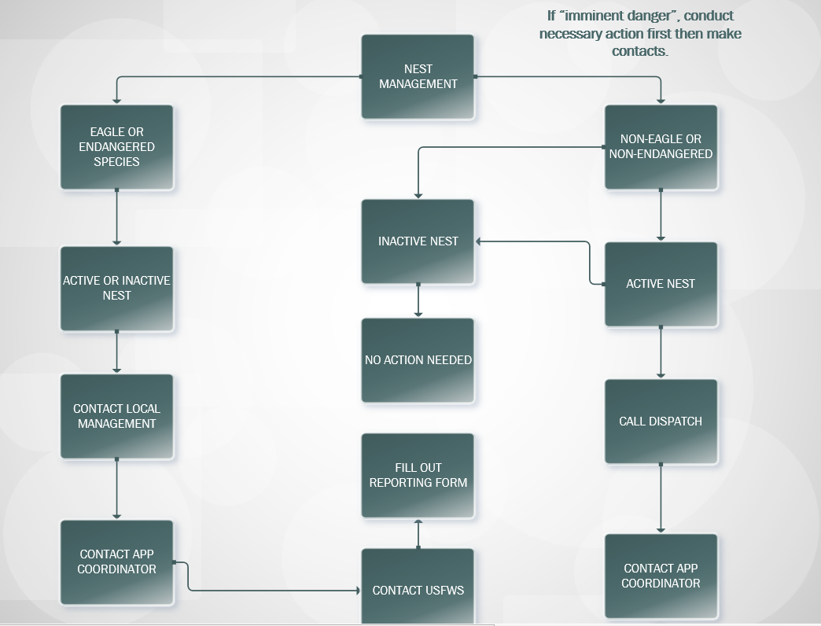

INSERT APP COORDINATOR’S PHONE NUMBER

**8.0 EVALUATION OF HIGH OR PROTECTED BIRD USE AREAS**

Bird species distribution in Missouri varies significantly depending on the season and available water features. Passerine and waterfowl species migrate through in the spring and fall. Shorebirds peak in mid-summer whereas bald eagles reach their highest Missouri numbers in the fall and winter. In fact, Missouri is one of the leading bald eagle states, with more than 2,000 reported in the state regularly during winter. Southern migration concentrates bald eagles near the outfalls of dams or power plant warm discharges where open water attracts waterfowl and gizzard shad may be caught. Nesting is concentrated along the larger rivers and reservoirs. COOP INITIALS will evaluate company equipment within a two-mile radius of known, active bald eagle nests and high roosts in a proactive effort to identify and eliminate potential collision/electrocution hazards for young birds.

Golden eagles do not live in Missouri year-round, but winter here in small numbers. Unlike, bald eagles, which are usually found near water, golden eagles hunt in open grasslands for a their prey. Bald eagles, in contrast, may use these structures, particularly around reservoirs, wetlands, or streams, as a substitute for large trees that they typically prefer. Both eagles desire high perches to hunt from and often choose power structures. As mentioned earlier, waterfowl move through Missouri in high numbers in spring and fall. In reservoir or wetland areas, given appropriate water and vegetation conditions, bird concentrations can number in the tens of thousands for short time periods. This same concentration spike can occur when few areas of open water remain on rivers or large reservoirs in midwinter and ducks and geese, pushed down by colder northern temperatures, congregate there. When high bird concentrations are combined with fog, rain, or snow, power lines near these waters are an increased risk for collisions.

Evaluations of our service territory for high bird use areas will continue over time based on scientific literature, input from ornithologists, breeding bird surveys, winter bird counts, observations by COOP INITIALS field personnel, and on-site pre-siting evaluations and consultations by COOP INITIALS environmental personnel. This data will inform company decisions on avoidance, minimization, and mitigation measures to eliminate or reduce the risk of collision and electrocution. Where possible, new lines should avoid areas of high bird concentrations and use natural vegetation and topographic features to reduce bird-power line interactions. COOP INITIALS environmental personnel will assist planning, design, real estate, and project management staff to identify regions known to congregate birds, or support important habitats for sensitive bird species. As a standard practice, COOP INITIALS environmental personnel will consult with the USFWS, MDC, and other stakeholders early in the process of evaluating potential new transmission line routes and substation locations. If necessary, COOP INITIALS will conduct pre-construction studies to assess risk to bird species.

In general, COOP INITIALS will take a 3-tiered approach:

* Preventative – Ensure through construction standards and pre-construction evaluations that all new construction is avian safe.
* Proactive – Retrofit or rebuild existing equipment as appropriate when an area of high bird use or critical habitat for a protected species is identified.
* Reactive – Retrofit or rebuild existing equipment in response to collisions and mortalities.

**9.0 REMEDIATION**

Mortalities recorded into the recording system typically have remediation measures designed to prevent future fatal interactions. On-site investigations include the equipment on which a mortality occurs and adjacent equipment. For example, on known problem poles, COOP INITIALS will evaluate the risk to birds on five additional poles each direction as recommended by APLIC. All remediation measures will be completed by the end of the calendar year of the reported mortality. Remediation actions and costs will be compiled and reported in the annual report to the USFWS.

**10.0 ADAPTIVE MANAGEMENT**

Many factors bring a level of uncertainty to all attempts to reduce bird/power line interactions. COOP INITIALS recognizes that overhead transmission lines, associated electrical equipment, and substations may cause injuries and deaths to birds in spite of implemented best management practices. As such, COOP INITIALS will systematically acquire and apply reliable scientific information to reduce bird electrocutions and collisions on our equipment. Using current scientific studies, work by other utilities, and APLIC, COOP INITIALS will undertake management actions proven to reduce injuries and fatal bird/power line interactions. With COOP INITIALS’s APP being in its infancy it will review and if needed update this APP in INSERT YEAR.

**11.0 CONSERVATION and EDUCATION**

COOP INITIALS will continue to pursue avian conservation and education opportunities throughout our service territory and the state of Missouri. COOP INITIALS is currently trying to develop these opportunities such as:

* Providing transportation of injured raptors to approved rehabilitation facilities
* Provide talks on COOP INITIALS’s APP to various stakeholder groups and at biological conferences
* Attend and support APLIC workshops
* Form an environmental volunteer group to provide a volunteer workforce for various surveys and other opportunities

**12.0 DEFINITIONS**

**Active Nest:** A nest with an adult bird sitting on eggs, or containing eggs and/or young birds. Term is used synonymously with “occupied nest.” Nests may be active through the breeding season (approximately January through August) depending on the species.

**Avian Safe:** Electrical equipment configuration design to minimize or eliminate collision and electrocution risk.

**Candidate Species:** Plants and animals for which the USFWS has sufficient information on their biological status and threats to propose them as endangered or threatened under the ESA, but listing is precluded by higher priority activities.

**Fledge:** A term indicating that a young bird has developed the necessary feathers and is able to fly.

**Imminent Danger:** Due to the presence of a bird nest, there exists significant danger of fire, electrocution to the birds, or immediate threat to human life or property. This is considered to be an exceptional situation.

**Inactive Nest:** A nest that is no longer in use by breeding birds or their young. Term is used synonymously with “unoccupied nest.”

**Incidental Take:** Take of a protected species that is incidental to, and not the purpose of, the carrying out of an otherwise lawful activity. Incidental take may be permitted under Section 10 of the ESA with development and implementation of a Habitat Conservation Plan or through Section 7 consultation through the Rural Utilities Service with USFWS.

**Insulate:** Using a non-conductive product designed to provide a barrier keeping wildlife from touching either two energized phases or an energized phase and a ground source.

**Isolate:** Using a product designed to keep wildlife completely off of power equipment.

**Missouri Raptor Safe:** Electrical equipment configuration designed to minimize or eliminate collision and electrocution risk to large birds of prey such as red-tailed hawks and great horned owls.

**Line Marker:** Device used to increase the visibility of electrical conductors or static wires.

**Nest Depredation:** The act of damaging or destroying an active nest of a protected species.

**Minimization:** Limiting the degree or magnitude of an activity that will affect birds or their habitats.

**Mitigation:** Compensation measures taken to offset species or habitat losses.

**Nest Encounter:** Coming across a bird nest located on or near electrical equipment during the course of routine or emergency activities.

**Non-native:** Species not originating in North America but now acclimated and reproducing in this region.

**Passerine:** Small to medium sized perching birds and songbirds.

**Perch Preventer:** An isolation device designed to keep birds, especially raptors, from perching, roosting, or nesting near energized equipment. NOT INTENDED TO COMPLETELY DISCONTINUE PERCHING, ONLY MAKE A LOCATION AWAY FROM ENERGIZED EQUIPMENT MORE APEALING.

**Problem Nest:** A nest that may cause electrocution and death to the birds or electrical outage, property damage, or otherwise interfere with power operations.

**Problem Line or Equipment:** A section of transmission line or piece of equipment that may cause death to the birds through collision or electrocution or create an electrical outage, property damage, or otherwise interfere with power operations.

**Protection Equipment:** Products designed to reduce or eliminate fatal bird interactions with electrical equipment.

**Protected Species:** These are animals that are legally protected by states or the federal government through laws, statutes, or regulations.

**Raptors:** Birds with hooked beaks and talons for grasping and killing prey, includes eagles, hawks, falcons, and owls. Raptors frequently use power poles for perching or nesting.

**Remediate:** Correcting a problem line or configuration to reduce or eliminate the risk of bird interaction and mortality.

**Retrofit:** Modification of existing electrical equipment to make it avian safe.

**Separate:** Increasing the distance between energized conductors or between energized conductors and grounded hardware. Separation may be accomplished by physically moving equipment or using protection equipment.

**Shorebirds:** Water-dependent shoreline, wetland, and grassland birds such as plovers and sandpipers.

**Stopover Habitat:** Areas where migrating whooping cranes stop to rest, roost, and feed during their spring and fall migration.

**Take:** legal term used in the MBTA, BGEPA, and ESA, defining various actions that negatively affect protected bird species.

**Waterbirds:** Water-dependent wading and marshland birds such as cranes, herons, gulls, and terns.

**Waterfowl:** Water-dependent birds such as ducks, geese, and swans.

**13.0 LITERATURE CITED**

About the Refuge - Salt Plains - U.S. Fish and Wildlife Service. (n.d.). *About the Refuge - Salt Plains - U.S. Fish and Wildlife Service*. Retrieved June 17, 2014, from <http://www.fws.gov/refuge/Salt_Plains/about.html>

Avian Power Line Interaction Committee (APLIC). 1994. Mitigating Bird Collisions with

Power Lines: The State of the Art in 1994. Edison Electric Institute. Washington, D.C.

Avian Power Line Interaction Committee (APLIC). 1996. Suggested Practices for Raptor Protection on Power Lines: The State of the Art in 1996. Edison Electric Institute/Raptor Research Foundation. Washington, D.C.

Avian Power Line Interaction Committee (APLIC). 2005. Avian Protection Plan (APP) Guidelines. Joint document prepared by APLIC and the US Fish & Wildlife Service.

Washington, D.C.

Avian Power Line Interaction Committee (APLIC). 2006. Suggested Practices for Raptor

Protection on Power Lines: The State of the Art in 2006. Edison Electric Institute, APLIC, and the California Energy Commission. Washington, D.C. and Sacramento, CA.

Department of the Interior, US Fish & Wildlife Service. 2011. General Provisions; Revised List of Migratory Birds; Proposed Rule. Federal Register Vol. 76, No. 80;

April 26, 2011.

**ATTACHEMENT 1**

**Dead Bird Recording Form**

Insert Coop Logo

|  |  |  |  |  |
| --- | --- | --- | --- | --- |
|  | **Dead Bird Form** |  | | |
| **Operations Area:** |
| **Dead Bird (circle one)**  Crow/magpie/raven | Eagle | **or** | **Nest (circle one)**  Active |
|  | Hawk/falcon/osprey  Small bird (protected) Unknown species | Owl  Waterfowl |  | Inactive |

# *Bird Count*

**Date Found Time Found**

**Sign of Death (circle one)**

Collision Electrocution Shot Unknown

# County

**Finder’s Name**

**Finder’s Phone**

**Line Name/Circuit No.**

**Pole Identification No.**

**Recommended Action (circle)**

*Dead Bird Actions Nest Actions*

Cover transformer equipment Install nest platform

Install insulator cover(s) Relocate nest

Install triangle(s) Trim nest

Reframe structure Install nest guards

Replace structure Remove nest

Evaluate to determine appropriate action

De-energize No action

Install bird flight diverters

Evaluate to determine appropriate action (Provide action in comments) Continue to monitor line (Justification required)

No action (Justification required)

# Comments

**ATTACHMENT 2**

**ACTIVE NEST ENCOUNTER FORM**

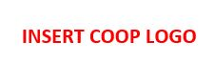**Active Nest Encounter Form**

**___________________** is under contract with INSERT COOP NAME Electric Cooperative, to clear dangerous/interfering foliage from Transmission Line Right Of Way. This document will record an encounter with an active nest.

**LOCATION OF TREE:_____________________________________________________**

**LOCATION OF NEST:_____________________________________________________**

**ADDRESS OR LEGAL DESCRIPTION: _______________________________________**

**CITY: ____________________________________________________________________**

**BIRD SPECIES: ___________________________________________________________**

**NEST SIZE:_______________________________________________________________**

**Eggs Present? Yes No How many?____________**

**Young Present? Yes  No How many?_____________**

**Action Taken? Avoid Removed**

**If nest removed, provide full justification: __________________________________________________________________________________________________________________________________________________________________________________________________________________________________________________________________________________________________________________________________________________________________________________________________________________________________________________________________________________________________________________________________________________________________**

**Crew Foreman:_______________________________ Date:____________________________**

**Date Work Completed: _________________________________________________________**

**Vegetation Management Supervisor: _____________________________________________**